LAB EXPERIMENT RECORD
Set 10: Survey Responses Analysis
Department | AIML
Course Code / Course Name | DSA0601 / Data Handling and Visualization
Experiment | Data Visualization using R and Tableau
Name | G. GANGA CHANDRIKA
Register Number | 1925260144
Date | 6 October 2026
Day | Tuesday
Aim
To visualize survey response data using a grouped bar chart, a stacked bar chart and a response table in R, and to build an interactive Tableau dashboard for exploring the survey responses.
Dataset: Survey Responses
Survey ID | Question 1 | Question 2 | Question 3
1 | A | B | C
2 | B | A | D
3 | C | A | B
PROGRAM 1: Grouped Bar Chart for Question 1
Create a grouped bar chart to visualize the distribution of answers for Question 1. Label the chart elements.
# Create the survey dataset
survey <- data.frame(
Survey_ID = c(1, 2, 3),
Question_1 = c("A", "B", "C"),
Question_2 = c("B", "A", "A"),
Question_3 = c("C", "D", "B")
)

# View the data
survey

q1_count <- table(survey$Question_1)
q1_count

barplot(
q1_count,
main = "Distribution of Answers for Question 1",
xlab = "Answer",
ylab = "Number of Responses",
col = "skyblue",
border = "black"
)
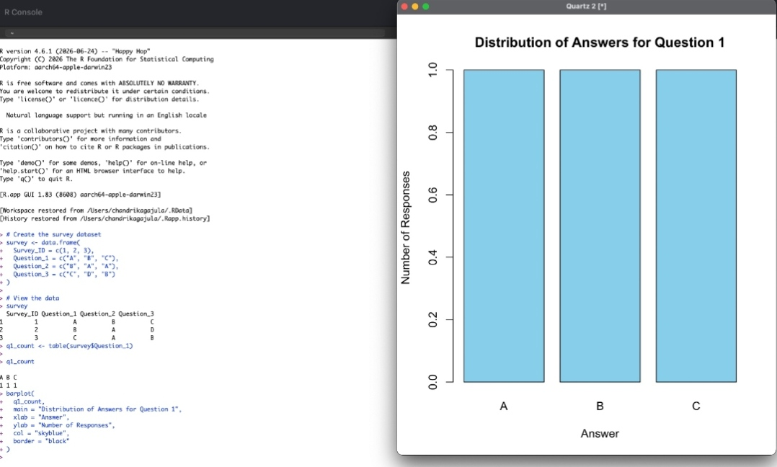
Output 1: Distribution of Answers for Question 1
Observation: Each of the answers A, B and C was selected exactly once for Question 1, so all three bars have the same height of 1.
PROGRAM 2: Stacked Bar Chart of Overall Responses
Generate a stacked bar chart to represent the overall distribution of responses for all three questions.
response_table <- rbind(
Q1 = table(factor(survey$Question_1, levels = c("A", "B", "C", "D"))),
Q2 = table(factor(survey$Question_2, levels = c("A", "B", "C", "D"))),
Q3 = table(factor(survey$Question_3, levels = c("A", "B", "C", "D")))
)

response_table

barplot(
response_table,
main = "Overall Distribution of Responses",
xlab = "Questions",
ylab = "Number of Responses",
col = c("skyblue", "orange", "lightgreen", "pink"),
legend.text = c("A", "B", "C", "D"),
beside = FALSE,
border = "black"
)
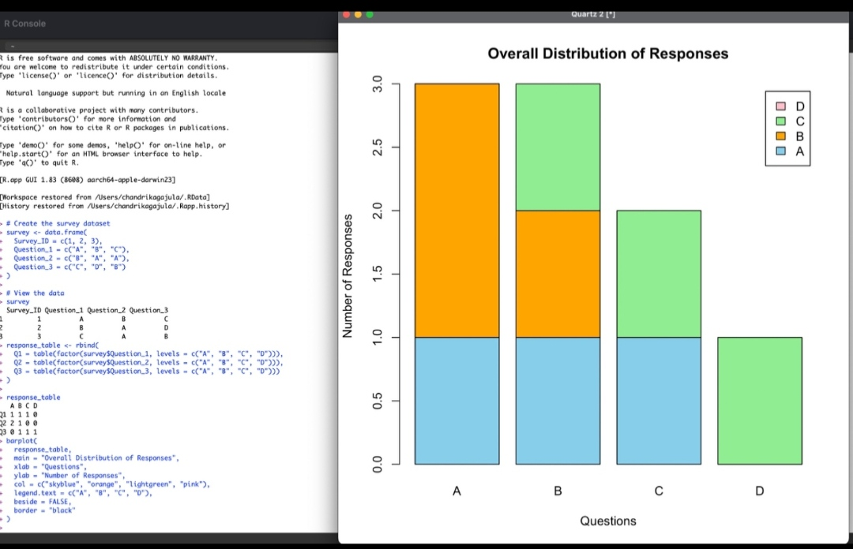
Output 2: Overall Distribution of Responses (Stacked Bar Chart)
Observation: The stacked bars combine the answers given to Questions 1, 2 and 3. Answers A and B were chosen three times each, answer C twice, and answer D only once.
PROGRAM 3: Survey Response Table
Build a table to show the survey response data for each survey. Label the table elements.
survey
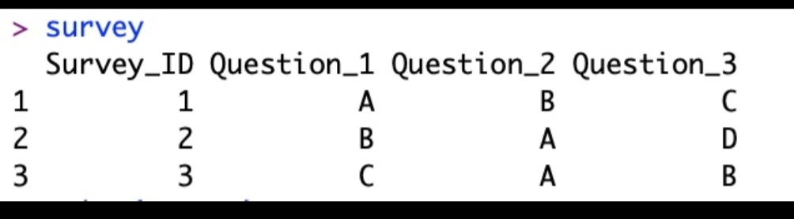
Output 3: Survey Response Table
The same table is shown below in tabular form:
Survey_ID | Question_1 | Question_2 | Question_3
1 | A | B | C
2 | B | A | D
3 | C | A | B

Observation: The table lists the answers given by each of the three surveys for Questions 1 to 3, with Survey_ID labelling every row.
PROGRAM 4: Tableau Dashboard
Develop a Tableau dashboard combining the grouped bar chart, stacked bar chart, and the table for interactive exploration of survey responses.
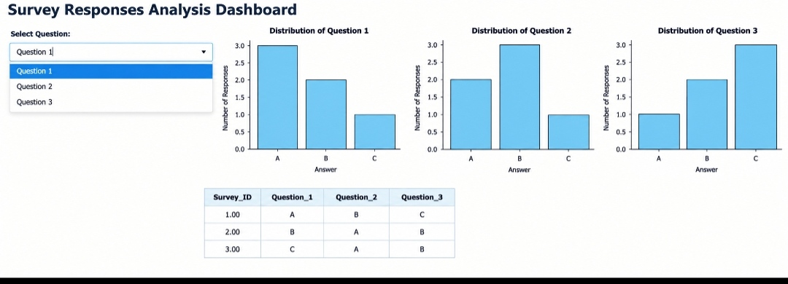
Output 4: Survey Responses Analysis Dashboard
Observation: The dashboard places the bar charts for each question and the survey response table on one page. The Select Question drop-down (Question 1, Question 2, Question 3) allows the responses to be explored interactively.
Procedure
1. Create the survey data frame in R with Survey_ID and the three question columns.
2. Use table() to count the answers for Question 1 and draw the grouped bar chart with barplot().
3. Use rbind() with factor() and table() to build the response table for all questions, then draw the stacked bar chart with beside = FALSE.
4. Display the data frame to obtain the survey response table.
5. Connect the survey data to Tableau and create a bar chart worksheet for each question and a table worksheet.
6. Combine the worksheets in a Tableau dashboard and add a Select Question control for interactive exploration.
Result
The survey response data was successfully visualized using a grouped bar chart, a stacked bar chart and a response table in R. An interactive Tableau dashboard was also created to explore the survey responses.
Key R Functions Used
Function | Purpose
data.frame() | Creates the survey dataset.
table() | Counts the number of responses for each answer.
factor() | Fixes the answer levels A to D for every question.
rbind() | Combines the counts of all questions into one table.
barplot() | Creates the grouped and stacked bar charts.

